`
Batch: A3 Roll No.: 1911034

Experiment / assignment / tutorial No.07

Grade: AA / AB / BB / BC / CC / CD /DD

Signature of the Staff In-charge with date

TITLE : User Defined Exception

AIM : Write a program which accepts marks of a student (between 0 to 100) and checks whether it is within the range or not. If it is within the range then it displays “marks entered successfully”, if not then it throws the exception of user defined class “MarksOutOfRangeException”. The class should contain appropriate toString method to describe object the class with the out of range marks entered by the user.
______________________________________________________________________
Expected OUTCOME of Experiment:

CO4: Demonstrate programs on interface, exceptions, multithreading and applets. _____________________________________________________________________
Books/ Journals/ Websites referred:

1.Ralph Bravaco , Shai Simoson , “Java Programing From the Group Up” Tata McGraw-Hill.

2.Grady Booch, Object Oriented Analysis and Design.

_____________________________________________________________________
Pre Lab/ Prior Concepts:

Exception Handling in Java:

Exception Handling is a special feature of Java, which allows the user to create additional conditions during code , to check for those places , where an exception might arise. In case the exception is caught by the default exception handler, it terminates the program abruptly.
However , exception handling allows the programmer to handle the exceptions (if they arise) in order to continue with the normal flow of the program. Exception handling also allows user to generate user defined exceptions and handle them as well.

All exceptions that are generated in java , are objects of the Parent Class ‘Throwable’. The Exception Classes hierarchy is as illustrated in the diagram below :

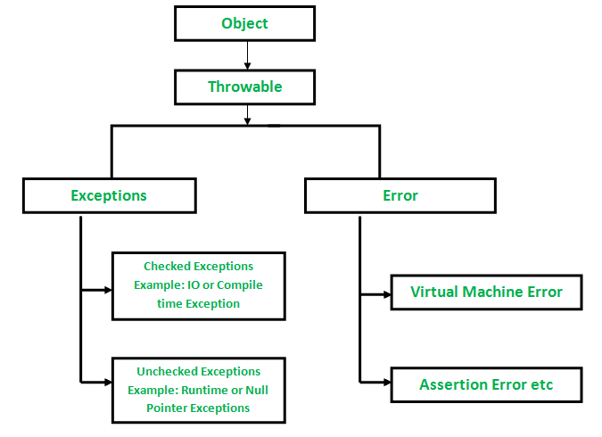

There are 3 important ways by which we can handle exceptions:

- By using Try-Catch

The try statement allows us to define a block of code to be tested for errors while the code is being executed. The catch statement allows us to define a block of code to be executed , in case an error is caught in the try block.

Syntax
Try
{
//code that might cause an error

}

Catch(Exception e)
{
//block of code to handle errors

}

- By using ‘Throw’ Keyword
The throw keyword in Java is used to explicitly throw an exception from a method or any block of code. We can throw either checked or unchecked exception. The throw keyword is mainly used to throw custom exceptions.
Syntax
throw Instance

Example
Throw new ArithmeticException(“/ by zero”)

Throw keyword can also be used to create user defined exceptions
- By using ‘Throws’ Keyword
throws is a keyword in Java which is used in the signature of method to indicate that this method might throw one of the listed type exceptions. The caller to these methods has to handle the exception using a try-catch block.

Syntax
type method_name(parameter list) throws exception_type
example
void divide(int a, int b) throws ArithmeticException

Class Diagram:

Class:
Public class Exp07
Methods:
Public static void main(String args[])
Variables:
int marks

Algorithm:
Step1: Define the class Exp09 with the main method , which accepts the marks of the student.
Step2: Define another class ‘MarksOutOfRangeException’ and extend parent class ‘Exception’ to it .The exception object that is generated will belong to this class.
Step3: Define constructor of the ‘MarksOutOfRangeException’ class which accepts the message to be displayed in case an exception object is thrown and pass the msg to super class constructor .

Step4: Accept the marks of the student and check whether marks are in the given range , i.e. whether marks >=0 && marks<=100 in the try block, in main method.

Step5: In case marks are in range , print ‘Marks entered successfully’

Step6: In case marks are out of range , throw an exception object of MarksOutOfRange exception in the try block , calling the constructor of the exception class with message to be displayed.

Step7: The catch block will catch the exception object thrown by the try block and it will print the exception object, in case the marks are out of range

Implementation details:(printout of code)
import java.util.*;

class MarksOutOfRangeException extends Exception /*user defined exception class*/
{

public MarksOutOfRangeException(String msg)
{
super(msg); /*calling super class constructor*/
}
}

public class Exp07

{
public static void main(String args[])
{
int marks;

System.out.println("Enter the marks of the student");
Scanner sc = new Scanner(System.in);
marks = sc.nextInt();
try
{
if ((marks<0)||(marks>100))
{
throw new MarksOutOfRangeException("Marks are out of Range"); /*used to throw an exception object*/
}

else
{
System.out.println("Marks successfully entered");
}
}

catch(MarksOutOfRangeException e)
{
System.out.println(e); /*used to print the exception object*/

}
}

}

Output Screenshots :
Printing exception message using user defined exception class :
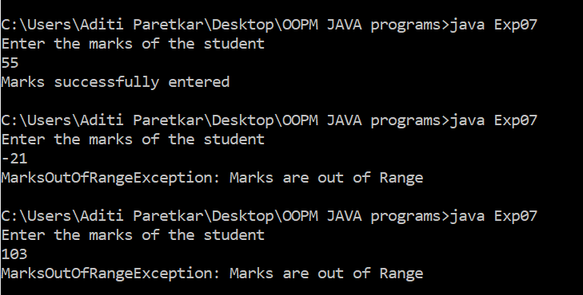

Conclusion:
In this experiment , we have learnt about exception handling in java , how to catch statements in java that can cause an exception using the try catch block , and how to generate user defined exception using ‘throw’ keyword and how to use ‘throws’ keyword in the signature of a method name to indicate when a particular method might throw an exception.

Date: ___________ Signature of faculty in-charge

Post Lab Descriptive Questions

- Compare throw and throws.
Throw | Throws
Java throw keyword is used to explicitly throw an exception | Java throws keyword is used to declare an exception
Example:  void method()  {  Throw new ArithmeticException(“exception”)  } | Example:  void method() throws ArithmeticException  {  //method code  }
Throw is followed by an instance | Throws is followed by a class
Throw is used within the method | Throws is used within the method signature
We cannot throw multiple exceptions | We can use declare multiple exceptions within the method signature. Eg  public void method () throws IOException, SQLException

- Explain how to create a user define exception and explicitly throwing exception in program with simple example.

A user defined exception can be created by using the ‘throw’ keyword. With the help of this keyword, the user can create an exception object , that belongs to the user defined Exception Class , which is a subclass of the class Throwable. The user defined exception can be handled by a try-catch block similar to custom exceptions.

Example:

class MyException extends Exception
{
public MyException(String s)
{
// Call constructor of parent Exception
super(s);
}
}

// A Class that uses above MyException
public class Main
{

public static void main(String args[])
{
try
{
// Throw an object of user defined exception
throw new MyException("Throwing exception object");
}
catch (MyException ex)
{
System.out.println("Caught the exception");

// Print the message from MyException object
System.out.println(ex.getMessage());
}
}
}

Output:
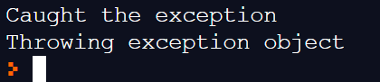

- Suppose the statement2 causes an exception in following try-catch block:

try {
statement1;
statement2;
statement3;
}
catch(Exception1 e1) {
}
catch(Exception2 e2){
}

statement4;

Answer the following questions:
- Will statement3 be executed?
Ans : no , because once the exception is caught by the try block , it immediately throws an exception object to the default exception handler , or to the catch blocks , and the statements after that in the try block are not executed.

- If the exception is not caught, will statement4 be executed?
Ans: no, if the statement is not caught by the catch blocks, it will be handled by the default exception handler which will terminate the program.

- If the exception is caught in the catch block, will statement4 be executed?
Ans: yes , if the statement is caught inside the catch block it will continue with the normal sequence of events and will not terminate the program , thus statement 4 will be executed

- If the exception is passed to the caller, will the statement4 be executed?
Yes it will be executed.

